Contact: GamePlan Team  Email: contact@athlete2career.com | Street 109 University Square  Erie, PA 16541  www.athlete2career.com | 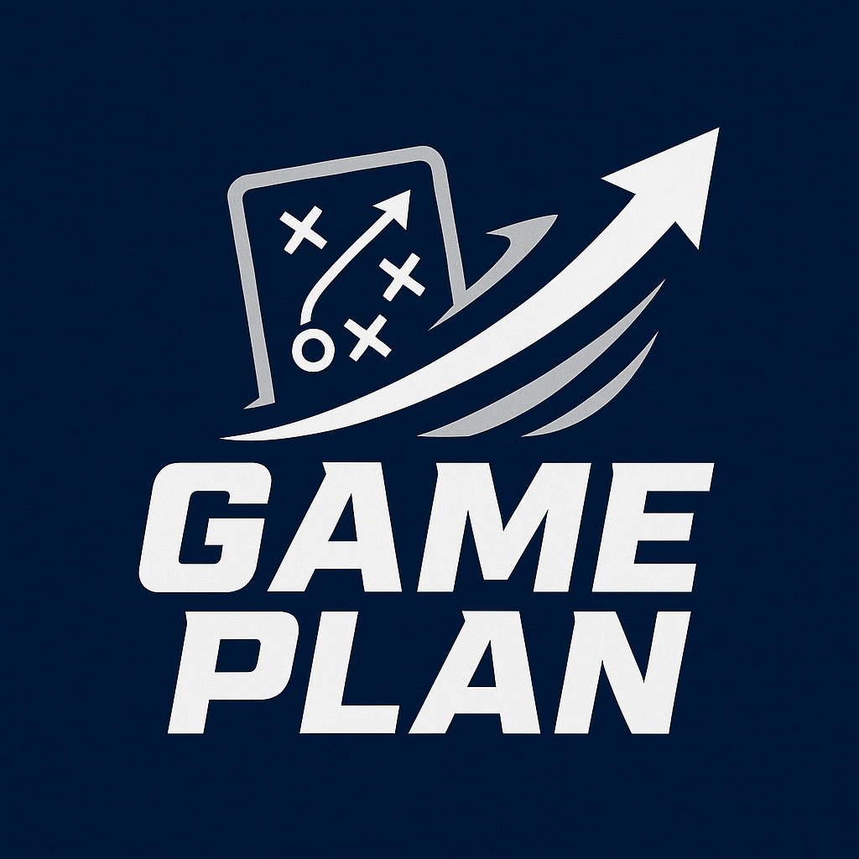

PRESS RELEASE

GamePlan: Empowering College Athletes for Life After Sports with New Career Transition Program
GamePlan launches in Erie, PA, offering resume coaching, networking, and job search support for student-athletes.

Erie, PA- April 20, 2025: A ground-breaking new program called GamePlan is starting in Erie, Pennsylvania, to assist undergraduate athletes in making the move from athletics to the professional ranks. The program was specifically designed for student-athletes, and offers crucial coaching, job search tools, and career development resources to help players thrive in life after graduation.
GamePlan gives student-athletes the opportunity to apply their leadership, time-management, and teamwork skills in the workplace by attending to their individual demands. The program provides tailored resources, including resume writing, networking opportunities, job search tools, and personalized coaching to help athletes succeed in their next stage of life.
“We wanted to create something that gives athletes the same kind of training for their future careers that they get on the field," said Jillian Heinrich, a GamePlan team member. "This project is all about showing student-athletes that their skills matter beyond the game.”

Join the Movement
To learn more about GamePlan or to get involved as a mentor, sponsor, or community partner, visit, www.gameplanathletes.com or contact us at contact@gameplanathletes.com
About Game Plan
A program called GamePlan assists collegiate athletes in making the move from sports to the professional ranks. GamePlan, a company based in Erie, Pennsylvania, helps athletes get ready for their next phase of life by providing professional development tools like networking opportunities, resume preparation, and individualized coaching.

